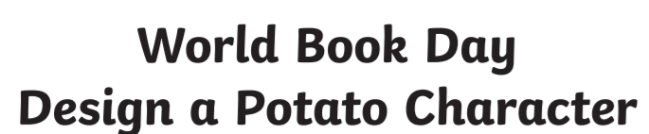
Disguise the potato below as your favourite book character.
What will the potato be wearing? Will it be holding something in its hand? Can you include a speech bubble and design a background?
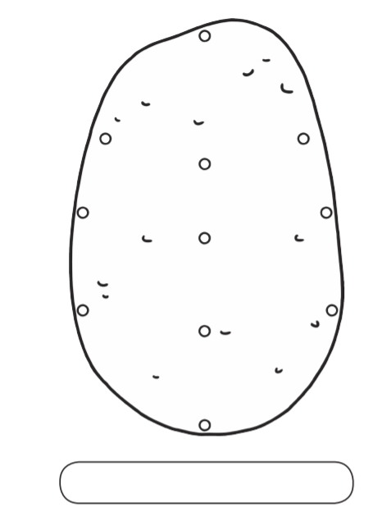
Can you write an explanation about your favourite character?
