Tuesday 23rd February
English
Finish the sentence
In the clouds I see….
For example: In the clouds I see ruby red dragon scales glistening in the scorching hot sun.
You can use the pictures below to help you think of some exciting sentences.
 |  | 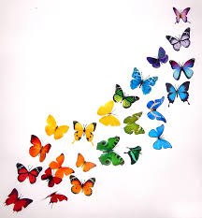
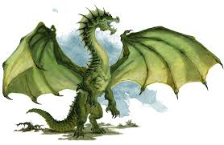 | 