Reading/Phonics | Literacy | Fine Motor Skills | Mathematics | Mathematics
We have subscribed to the new Oxford Owl paid reading ebook collection. Please go to www.oxfordowl.co.uk  Click on ‘Oxford Owl for School’ then select ‘Log in’. Select ‘Students’ and in ‘Class or student username’ type gisreception and the password gisreception (All lower-case letters)  Select ‘Oxford Owl eBook Library’ and then type ’Hats’ in the eBook Library search.  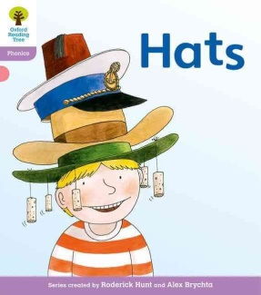  Please get your child to read the repeated language sentences in this book to you and use their phonics skills to sound out unknown words. | Purple Mash-Oxford Reading Tree 2 Create Task  Can you draw a picture of you wearing your favourite type of hat like in the story ‘Hats’? Can you then write ‘Your name’ has a (what kind of hat?) | We have been working hard on promoting independence and resilience in Reception.  Please encourage and work with your child to put on and zip up their coat independently.  What do you need to do if your sleeve is inside out? | Purple Mash – Part Whole Model quiz.  The whole is the total that the two parts equal.  If you need your child’s login please email us. | Can you use household objects or draw images to show your own part-whole models to make different numbers within 10?  Challenge – can you write your part-whole models as addition calculations?
Reception Homework-Week Beginning 15.03.21

Homework will be sent out on a Monday and due by the following Monday. We will be sending out 5 tasks for your child to complete at home, these will be a mix of Literacy and Mathematics.

Please email us any homework, if you have any questions or if you need your child’s Purple Mash login - gis.reception@schools.sunderland.gov.uk

